My health and wellbeing in prison and beyond (women) Part 2

Unit 3

Pregnancy and having a baby in prison



Contents

Unit 3 Pregnancy and having a baby in prison: teachers’ notes

Unit 3 Pregnancy and having a baby in prison: learner resources

Unit 3 Pregnancy and having a baby in prison: answers and appendices

Overview
This unit involves reading texts centred on mother and baby units (MBU) and antenatal care. It introduces useful vocabulary for antenatal care and allows lots of opportunity for discussion.

Level: Entry level 1-3 / National 2 – 4 / CEFR A1 - B1

Time: Approximately 90 minutes. Timings are flexible and teachers can break down the units into smaller chunks of learning and build in revision as required.
Aims

For all learners:
- To introduce essential vocabulary for talking about antenatal care
- To provide opportunity to read these words in context
- To facilitate discussion about pregnancy, antenatal care and staying healthy during pregnancy

For Pre-entry / beginner
- To introduce the words pregnant, mother, baby, girl and boy and practise reading and writing these words
- To raise awareness of a set of 8 lexical items associated with antenatal appointments
- To use texts to contextualise this vocabulary
- To allow opportunity to hear words in context during discussion and participate in discussion albeit in a limited way

For Entry 1/ National 2
- To check understanding of some essential family vocabulary and practise structuring sentences using this vocabulary
- To raise awareness of a set of 8 lexical items associated with antenatal appointments
- To use texts to contextualise this vocabulary
- To introduce simple adjectives to talk about feelings during pregnancy (optional)
- To provide opportunity to hear new vocabulary in context during discussion and participate in discussion albeit in a limited way

For Entry 2 and 3
- To provide opportunity to read for gist and detailed information in a text about MBUs
- To introduce a set of 15 lexical items associated with antenatal appointments
- To use authentic texts to contextualise this vocabulary
- To introduce and practise using comparative adjectives (optional)
Objectives
All learners will be able to:
- recognise and understand at set of words associated with antenatal health checks (appropriate to level)
- read texts to find these words in context (appropriate to level)
- discuss what is healthy or unhealthy for you and your baby during pregnancy (appropriate to level)
Some learners (optional) will be able to:
- read a text about MBUs to understand gist, detailed information and vocabulary items (Entry 2/3 / National 3/4)
- read and understand a limited number of basic words for talking about pregnancy and family (Pre-entry / beginner / Entry 1 / National 2)
Preparation
You will need:
For yourself
Print a copy of the answer sheets.
You will find it useful to read up on MBUs and refer to the ‘The Pregnancy Book’ – an NHS publication (particularly Section 3 – Your health in pregnancy) prior to the lesson. Information on MBUs is included as Appendix 1 at the end of this resource, and ‘The Pregnancy Book’ is included as a PDF. The information is also available on these sites;
MBUs:
http://www.justice.gov.uk/offenders/types-of-offender/women
https://www.gov.uk/life-in-prison/pregnancy-and-childcare-in-prison.
The Pregnancy Book:
Whole book: http://webarchive.nationalarchives.gov.uk/20130107105354/http:/www.dh.gov.uk/prod_consum_dh/groups/dh_digitalassets/@dh/@en/@ps/@sta/@perf/documents/digitalasset/dh_107688.pdf
By chapter: http://www.publichealth.hscni.net/publications/pregnancy-book-0

For everyone
Resource 1 – one set, in colour if possible
Resource 2e – (optional - if doing running dictation. (See Activity 1 notes), one set.
Resource 3 – one set per pair or small group, cut up and shuffled. The first 8 words / pictures only for beginner/lower levels, all cards for more proficient learners.
NB: If you have the facilities, it is a good idea to print resource 3 in colour and laminate for repeated use.
Resource 4 – one set per pair or small group, cut up and shuffled.

For your beginner learners
Resources 1a, 2a and 3a, one of each per learner

For your Entry 1/National 2 learners
Resources 1b, 2a and 3a (optional), one of each per learner

For your Entry 2/National 3 learners
Resources 1c, 2b and 3b (optional), one of each per learner
Resource 4, cut up and shuffled, one per learner

For your Entry 3/National 4 learners
Resources 1d, 2b and 3b (optional), one of each per learner
Resource 4, cut up and shuffled, one per learner

Suggested Procedure
Warmer and lead-in (5 minutes)
- Display the pictures in resource 1. On the whiteboard / flipchart, write up jumbled versions of the words baby, mother, girl, boy, pregnant, son and daughter, e.g. aybb for baby, omreth for mother, etc. Learners guess the word and unjumble the letters.
- If necessary, drill the words individually and in a sentence, e.g. ‘I am pregnant,’ ‘I have a boy and a girl.’
- By way of a diagnostic for the topic, ask learners if they know anyone who has had a baby recently. Where did they have their babies? Did they see a doctor while pregnant? They may be happy to talk about their own experiences too, but be sensitive. There may be some who have lost a child, or have had a child taken into care. Others may prefer not to talk about themselves. If learners prefer not to participate in the discussion, don’t push it.

Activity 1 – Reading and discussion about MBUs 15 – 30 minutes
! Be sensitive with this topic. Whilst it is useful for learners to know about MBUs, there may be learners in your class who have applied and have been refused places. If you know this to be the case, you may want to skip straight to Activity 2.

- Write up the initials MBU and see if the learners can tell you what it means. If they don’t know, tell them (mother and baby unit). Don’t elicit too much information about MBUs yet; some learners will be finding out information from a reading text.
- Set beginner learners resource 1a and E1/N2 learners resource 1b.
- Learners using resource 1a look at each picture and read the word below it. They then write over the top of the light grey text. Finally, they copy the word onto the line below.
- In resource 1b task 1, learners read the words in the blue box then match them by writing each one below its corresponding picture. Next, they look at task 2 and put the words in order to make good sentences. Finally, in task 3, they match the initial to its meaning by drawing a line. As an extension to resource 1b, learners could write or copy some sentences about themselves.
- Tell more advanced learners they are going to read about MBUs. Check they understand the meaning of a heading, perhaps by pointing to one on a poster, or writing an example on the board / flipchart. Give E2/N3 learners resource 1c and E3/N4 learners resource 1d. Encourage them to read the instructions for each task to you and check they understand how to complete them, e.g. ask ‘Where do you write the headings?’ ‘Which words are in grey?’ ‘What does accommodation mean?’ ‘What do you do in task 3?’
Alternative activity
- If only learners at E2/N3 and above are present, they could do a running dictation. Don’t give out resources 1c and d yet. The procedure is as follows:
  - Stick the five sentences from the MBU text (resource 1e) spaced out on a wall at the far end of the classroom. Arrange your learners in mixed ability pairs to make the game fairer and allocate each pair one of the sentences.
  - Learner A of must sit far from the sentences, ready to write. Learner B moves between the sentence and her partner. Learner B must read, remember and relay the information in their sentences in stages to learner A, who must write it down.
  - Make it a rule that no shouting is allowed. Give longer sentences with more complex vocabulary (e.g. sentences 1 and 2) to stronger readers / writers.
  - The winning pair is the pair that finishes their sentence first. You can insist on accuracy and underline anything they need to go back and correct.
- When finished, go on to complete the tasks on resource 2c and 2d.
- Go through the answers together, or have learners check their own work. Use the content of the reading texts to stimulate discussion. Some questions you could ask;
If learners are living in an MBU:  Do you like living here? Why / why not?  How is it different from the main wing?  What facilities are there? | If not:  Does your prison have an MBU?  What do you know about MBUs?  Have you lived in an MBU in the past?  Do you know how to apply to an MBU?
Follow-up / extension activities
Learners could;
- Practise filling in an application form for an MBU. This is a good opportunity to use an authentic text in class.
- Write an information leaflet outlining the facilities in an MBU for expectant mothers;
- Bring in some leaflets and look at the features (pictures, headings, bullet points, text boxes, etc.).
- As a group, brainstorm the information about MBUs you need to include (you could provide this, if learners have never visited an MBU before).
- Bring in coloured felt-tips and paper for learners to make their own leaflets.
Activity 2 – Vocabulary activities – Words used in antenatal appointments (20 minutes)
- Assess prior knowledge by asking about appointments you have when you are pregnant; Who do you see? What do they check? What do you talk about?
- Learners work in groups of two or three to match the blue and white vocabulary cards in resource 2. Mix lower level learners and give them the first 8 words and pictures only. E2/N3 and above should have all cards. This is a good opportunity for peer teaching, so don’t intervene too much during the activity.
- Go through answers and elicit explanations for the words when learners have finished. Drill the words and allow learners time to write them down if they wish.
- Follow up with some discussion: Have learners had these tests? Why do they do these tests? Do any of them hurt? Is it easy to get appointments with the midwife in their prison? Who is the midwife and what’s her / his name?
- Resources 2a and 2b provide the opportunity to see the words in context and read for understanding. Resource 2b centres on an authentic NHS text, taken from ‘The Pregnancy Book,’ which contains information about what to expect at each stage of your pregnancy. Please note, this needs to be used with resource 2c. Resource 2a (lower level) is two antenatal appointment cards.
- Give out the appropriate resource to each learner and give them time to complete the activities individually. Ask learners using the appointment cards texts (lower level) simple comprehension questions orally, (e.g. What day is Habiba’s appointment? What time?), while the other learners are completing their reading tasks.
Follow-up / extension activities
- Learners could use the blue cards from resource 2 to play ‘Guess the word’. Working in pairs, or teams, one learner picks a blue card from the pile. She must describe or draw the word. The other members of her team must guess the word. This can also make a fun whole-class game. Give one member of every team the same word. Whichever team shouts the correct answer first wins a point. Use mixed ability groups for this, and have a higher level learner do the talking.
Activity 3 Comparative adjectives (15 - 20 minutes)
- There are examples of comparative adjectives in the NHS text. Use this as an opportunity to work in some practise of comparative adjective with learners at E2/N3 and above using resource 3b. Here are the rules for comparative adjectives.
Short adjectives of one syllable | Add –er.  Spelling change for words ending in a consonant-vowel-consonant: double the last consonant, e.g. big – bigger. (NB: this rule doesn’t work for w or y, e.g. slow – slower, not slowwer)
Adjectives ending in consonant +y | Change the y to an i, then add –er, e.g. easy - easier
Adjectives two syllables or longer that don’t end in a consonant+y | Don’t add –er, use more + adjective, e.g. interesting – more interesting

- The easier resource 3a for pre-entry / beginner and Entry 1 takes a look at simple adjectives to describe feelings during pregnancy.
Activity 4 – Vocabulary and discussion (20 minutes)
- Elicit a couple of examples of things that are good or bad for you and your baby when you are pregnant.
- Pre-teach some of the trickier words, e.g. supplement, folic acid, vitamin. Also, for the benefit of the lower levels, teach ‘It’s good for you’, ‘It’s healthy / unhealthy’
- Put learners in mixed ability groups for peer teaching of vocabulary. Give each group a set of words from resource 4 and ask them to discuss which are good and bad for you or your baby when you are pregnant. Encourage higher-level learners to give a reason. They should categorise the cards into two groups leaving any they aren’t sure about to the side.
- After a few minutes, go through the answers as a class, encouraging discussion and drilling new or tricky words. Refer to The Pregnancy Book (Section 3 – Your health in pregnancy) or, if you are able, go online NHS Choices for detailed and the most up-to-date information prior to class. You may also be able to access NHS resources on pregnancy (in prison) through your healthcare team. You could arrange for a member of the healthcare team to join the lesson.
Follow-up / extension activities
- If you have completed Unit 3 (Healthy Lifestyle) from this topic, you could revisit ‘should’ and ‘shouldn’t’. Learners could write some advice on staying healthy for pregnant women, or role-play giving advice to a pregnant friend.
- Use the activity as a basis for discussion about how easy it is to access / avoid some of the things in resource 4 when you are pregnant in prison.
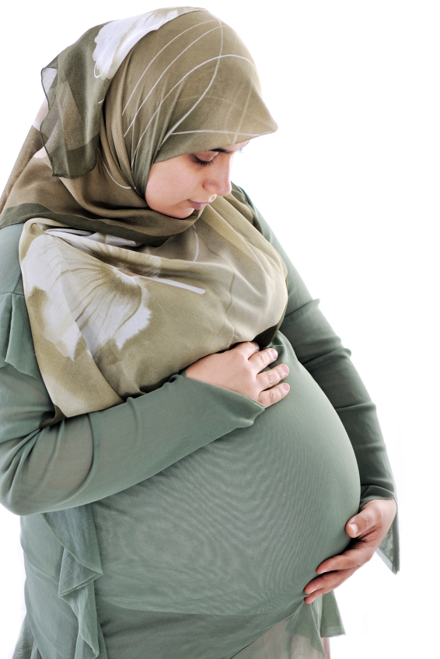
- Resource 1 - Pictures for lead- in

_________________________________________________________________________________
- 

Resource 1


___________________________________________________________________________

- 

Resource 1a (Pre-entry / beginner)
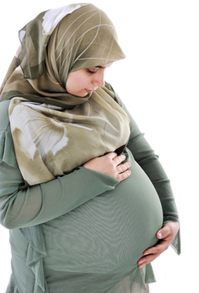 |  | 
pregnant | mother | baby
pregnant | mother | baby
............................................... | ............................................... | ...............................................

 | 
Girl | boy
Girl | boy
............................................... | ...............................................

Resource 1b (Entry 1/National 2)

1. Write the words from the box under the pictures.

mother baby pregnant girl boy

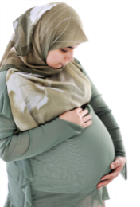 |  |  | 
......................................... | ......................................... |  | .........................................
 |  | 
......................................... |  | .........................................

2. Put the words in order to make good sentences. Add a full stop.

am I pregnant .................................................................................

mother I a am .................................................................................

a have I baby .................................................................................

girl I boy a have a and .................................................................................

Now tick () the sentences which are true for you.

3. Match the initials to the word.

M |  | baby
B |  | mother
U |  | unit

Resource 1c Reading (Entry 2/National 3)

Mother and baby units (MBUs)

(1) ........................................................

They are accommodation in prison where you can live with your baby usually until he or she is 18 months old. You are responsible for the day-to-day care of your baby while you are living in the MBU.

(2) ........................................................
There are seven MBUs in the UK and there are 77 places in total.

(3) ........................................................
You have to show that you are a suitable parent that can look after your baby. You also have to show that you can get on with the other people in the unit.

1. Read the text about MBUs. Match the headings to the numbers.How can I apply for a place in an MBU?
How many MBUs are there?
What is an MBU?

2. Look in the words in grey. Which word or phrase means...?

- a good mother
- be friendly with
- somewhere you live
- take care of
- the person in charge of

Resource 1d (Entry 3/National 4) Reading

Mother and baby units (MBUs)

(1) ........................................................

They are accommodation in prison where you can live with your baby usually until he or she is 18 months old. You are responsible for the day-to-day care of your baby while you are living in the MBU.

(2) ........................................................
There are seven MBUs in the UK and there are 77 places in total.

(3) ........................................................
You have to show that you are a suitable parent that can look after your baby. You also have to show that you can get on with the other people in the unit.

1. Read the text about MBUs. Think of a question that you can use as a heading for each paragraph.

2. Look at the text again. Find a word or phrase that means...

- a good mother
- be friendly with
- somewhere you live
- take care of
- the person in charge

3. Find and underline these numbers in the text; 77, 7 and 18. What do the numbers mean?

Number | What does it mean?
77
7
18
Resource 1e Running dictation (optional)

1.
They are accommodation in prison where you can live with your baby usually until he or she is 18 months old.
2.
You are responsible for the day-to-day care of your baby while you are living in the MBU.
3.
There are seven MBUs in the UK and there are 77 places in total.
4.
You have to show that you are a suitable parent that can look after your baby.
5.
You also have to show that you can get on with the other people in the unit.

Resource 2 Match the word to the picture

weight |  | height | 
midwife |  | blood pressure | 
due date | 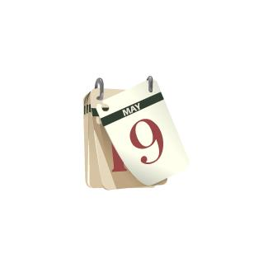  the date your baby will be born | uterus | 
ultrasound scan | 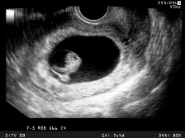  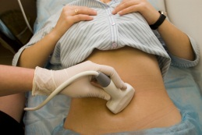  a look inside your body to see your baby | screening test |     a test to check your baby is OK – usually a blood test or scan
For learners at lower levels use the first eight words (above) only..

family history | information about any health problems in your family | urine sample | 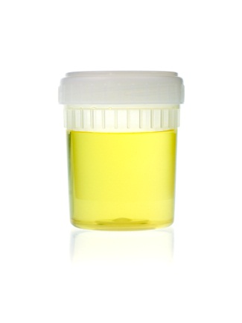
anaemia | a health problem in which you don’t have enough red blood cells | heartbeat |   
antenatal care | healthcare you have when you are pregnant – antenatal means ‘before birth’ | measure | find out how big, heavy, strong etc. something is

Resource 2a Vocabulary in context

HMP Red Hall

Appointment with the midwife

Name: Habiba
When? Monday 11 July
What time? 2.00 p.m.

What will happen?

The midwife will;

- check your weight
- check your height
- talk to you about ultrasound
- talk to you about your health and your family’s health

HMP Red Hall

Appointment with the midwife

Name: Sofia
When? Friday 15 July
What time? 10.00 a.m.

What will happen?

- You will have an ultrasound.
- The midwife will tell you your due date.

Resource 2a (continued)

- Habiba and Sofia are pregnant. Read their appointment cards. Can you see any of the words you practised? Circle them.

- Answer the questions. Circle the correct answer.

- The appointments are with the doctor / the midwife.
- Habiba’s appointment is on Monday / Friday.
- Sofia’s appointment is at 2.00 p.m. / 10.00 a.m.
- Habiba / Sofia’s appointment is on the 11 July.

- Read again. Tick () the right box. Who will...?

 | Habiba | Sofia
have her weight checked
have an ultrasound
have her height checked
learn her due date

4. Extra activity (if you have time)

Choose four words from the appointment cards. Practise your spelling. Look, say, cover, write, then check.

Resource 2b - Vocabulary in context
Excerpt from ‘The Pregnancy Book’ (produced for the Department of Health).

Resource 2b (continued) – Vocabulary in context

1. Look at the text. What is it about?

- your baby

- fruit and vegetables

- what happens when you are pregnant

- getting clothes for your baby

2. Can you see any of the words you practised? Circle them.

3. Your teacher will give you some sentences. Read the text and place the sentences in the correct column below.

16-20 weeks | 20-25 weeks

4. Extra activity (if you have time)
Look at these two sentences from the text.
You may start to feel your baby move.
You will begin to feel your baby move.
Which one is more certain?
Check the text. Which sentences in the table may happen and which will happen?
Resource 2c (to use with resource 2b) What happens when you are pregnant
Cut up and shuffle, one set per pair of learners.

You feel hungry. | The midwife takes your blood pressure.
Your uterus is bigger. | You discuss your screening test results.
You start to feel your baby move. | You look pregnant.

Resource 3a - Adjectives

Adjectives are words that describe something. They can describe how you are feeling.

Amy is very happy today.

happy is an adjective.

1. Circle the adjectives in these sentences.

- Amy is very happy today.

- How are you? I’m fine, thanks.

- I’m excited. I’m really happy about it.

- I’m tired. I’m going to bed.

- You look sad. Is everything OK?

- I’m worried. I think something is wrong.

- She is surprised. She didn’t know she was pregnant!

- She’s very relaxed. She never worries about anything.

2. Write the adjectives you circled in the box below.
3. How do you feel when you are pregnant? Circle the adjectives in the box above.

4. Extra activity (if you have time). Write some sentences about how you feel today.

Resource 3b – Comparative adjectives

When you are pregnant, your body goes through lots of changes. We can use comparative adjectives to describe something now compared to something before.

1. Read the text again. Find and underline the comparative adjectives of these words;

big .........................................................
loose .........................................................
hungry .........................................................

What do the words above describe in the text?

Why do we use comparatives? What are the rules for spelling comparatives? What about longer adjectives?

2. Write the comparative adjectives of these words.

small .........................................................
tired .........................................................
heavy .........................................................
strong .........................................................
emotional .........................................................
difficult .........................................................
happy .........................................................
3. Use a comparative adjective from question 2 to fill these gaps.

- You may begin to feel ............................................. and want to sleep more.

- When you are pregnant, you get ...............................................

- At 14 weeks, your baby’s heartbeat will be getting .................................................

.
Resource 4 (all levels)
Teachers – It is important you refer to ‘The Pregnancy Book’ pages 24-34 or the NHS Choices website for detailed information before doing this activity with your group.

good
fruit
vegetables
low-fat yogurt
keeping active
eating breakfast
folic acid
vitamin D
Bad
soft cheese
raw meat
liver
vitamin A
runny eggs
lots of coffee
smoking
drinking alcohol
using illegal drugs
high-fat food
Add your idea:

Add your idea:

Unit 3 Pregnancy and having a baby in prison – answers

Answers to Resource 1c and 1d

1 | Paragraph 1 – What is an MBU?  Paragraph 2 – How many MBUs are there?  Paragraph 3 – How can I apply for a place in an MBU?
2 | - a good mother - a suitable parent  - be friendly with – get on with  - somewhere you live - accommodation  - take care of – look after  - the person in charge of – responsible for

Answers to Resource 2a
1 | Learners may have circled midwife, weight, height, ultrasound and due date.
2 | - The appointments are with the midwife.  - Habiba’s appointment is on Monday.  - Sofia’s appointment is at 10.00 a.m.  - Habiba’s appointment is on the 11 July.
3 | Habiba Sofia  have her weight checked  have an ultrasound  have her height checked  learn her due date

Answers to Resource 2b
1 | The text is about what happens when you are pregnant.
2 | The learners may have circled midwife, screening tests, blood pressure, urine, anaemia, uterus and antenatal.
3 | 16-20 weeks 20-25 weeks  You start to feel your baby move. (Can be in either column) You discuss your screening test results. The midwife takes your blood pressure. Your uterus is bigger. You look pregnant. You feel hungry. You start to feel your baby move. (Can be in either column)
4 | may is used when something is possible in the future, but not certain.  will is used when something is certain to happen in the future.  The text tells us:  At 16-20 weeks You may start to feel your baby move.  At 20-25 weeks Your uterus will begin to get bigger; you will really begin to look pregnant; you may feel hungrier; you will begin to feel your baby move.

Answers to Resource 3a
1 | The words underlined are adjectives.  - Amy is very happy today.  - How are you?  I’m fine, thanks.  - I’m excited. I’m really happy about it.  - I’m tired. I’m going to bed.  - You look sad. Is everything OK?  - I’m worried. I think something is wrong.  - She is surprised. She didn’t know she was pregnant!  - She’s very relaxed. She never worries about anything.

Answers to Resource 3b
1 | The learners should have underlined;  bigger, looser and hungrier.  bigger describes ‘your tummy’ or ‘your uterus’  looser describes clothes you will need  hungrier describes how you feel  Short adjectives of one syllable Add –er. Spelling change for words ending in a consonant-vowel-consonant: double the last consonant, e.g. big – bigger. (NB: this rule doesn’t work for w or y, e.g. slow – slower, not slowwer)  Adjectives ending in consonant +y Change the y to an i, then add –er, e.g. easy - easier  Adjectives two syllables or longer that don’t end in a consonant+y Don’t add –er, use more + adjective, e.g. interesting – more interesting
2 | small – smaller tired – more tired heavy – heavier strong – stronger  emotional – more emotional difficult – more difficult happy - happier
3 | Suggested answers (accept reasonable alternatives)  a) more tired b) more emotional c) stronger

Appendix A

Text from Ministry of Justice (2012) http://www.justice.gov.uk/offenders/types-of-offender/women Accessed 18/10/14;

Mother and baby units
A mother and baby unit (MBU) is designated separate living accommodation within a women's prison, which enables mothers to have their children with them whilst in custody. Mothers on MBUs retain parental responsibility for their children and are responsible for their day-to-day care.
Applicants for a place on an MBU must be able to demonstrate that they are suitable and, primarily, that having an MBU place is in their child's or children's best interests. Mothers must also show that their presence on the unit will not be detrimental to the well-being of other children on the unit. Mothers must continue to demonstrate appropriate behaviour while on the unit so that the children's best interests continue to be met..
There are currently seven MBUs within women's prisons in England. These are located at Styal, New Hall, Eastwood Park, Holloway, Askham Grange, Peterborough and Bronzefield. The national capacity is 77 places for mothers (84 spaces in total to allow for twins), and each Unit has the capacity to accommodate one set of twins.
Babies can remain with their mother on an MBU up to 18 months of age (except for at Holloway which caters for babies up to 9 months), but this may vary a little depending on circumstances.

Younger women prisoners
Young women aged between 18 and 21 are known as young adult women. In the women's estate they reside in designated accommodation within women's prisons, but depending on risk assessment, may take part in the full range of activities available to all prisoners.
Young women aged under 18 are held in Young Women's Units, which are separate units within women's prisons. There are three dedicated units - the Jospehine Butler Unit at Downview, the Mary Carpenter Unit at Eastwood Park and the Rivendell Unit at New Hall. The Youth Justice Board are responsible for placing young people in custody and NOMS Young People's Team oversees the arrangements.
Appendix B

Text from GOV.UK (2014) https://www.gov.uk/life-in-prison/pregnancy-and-childcare-in-prison. Accessed 3/3/15

5. Pregnancy and childcare in prison
Women who give birth in prison can keep their baby for the first 18 months in a mother and baby unit.
A prisoner with a child under 18 months old can apply to bring their child to prison with them.
Social Services arrange for children over 18 months to be cared for, eg by the prisoner’s parents, or fostering.

Applying for a place in a mother and baby unit
- The prisoner can apply for a space in a mother and baby unit when they enter prison.
- An admissions board will decide if it’s the best thing for the child.
- If there are no places in the prison the mother first goes to, they may be offered a place in another unit.
- If there are no spaces in any unit, arrangements must be made for the child to be cared for outside prison.
- If the mother is refused a place they can appeal - the prison will explain how.
- Separation plans are made when the mother enters prison if the child will reach 18 months before her sentence is over.
For prisoners with sentences of 18 months or over, arrangements are normally made for the child to be cared for outside prison.

Prisons with mother and baby units
The following prisons have mother and baby units:
- Bronzefield
- Eastwood Park
- Styal
- New Hall
- Peterborough
- Askham Grange
- Holloway (takes children up to 9 months)

Information obtained from Ministry of Justice (2012) Women Prisoners http://www.justice.gov.uk/offenders/types-of-offender/women Accessed 5/7/14
Information obtained from Ministry of Justice (2012) Women Prisoners http://www.justice.gov.uk/offenders/types-of-offender/women Accessed 5/7/14

